DIGITAL LITERACY PROJECT REPORT

Name: Parv Agrawal
Registration Number: 25MIM10225
Branch: CSE(Intregrated M.Tech.)
Year: First Year
Course Code: CSE0001
Date: 31/03/2026

Introduction
Digital literacy is an essential skill in today’s technology-driven world. This project focuses on developing awareness about digital tools, safe internet practices, and professional online communication. As a Digital Ambassador, the aim is to guide peers in using digital platforms responsibly and effectively. This project includes tasks related to infographic creation, building a digital portfolio, exploring coding platforms, understanding email etiquette, and studying cybercrime awareness.
Task 1 – Infographic
For Task 1, I created a digital literacy awareness infographic using Canva. The infographic includes key topics such as digital literacy definition, useful digital tools, email etiquette, and safe internet practices. I used icons, colors, and structured layouts to make the design visually appealing and easy to understand.
This task helped me understand how to present information in a concise and engaging format. I found it interesting to use design elements to improve clarity. The main challenge I faced was organizing all the information in a single page while maintaining readability.
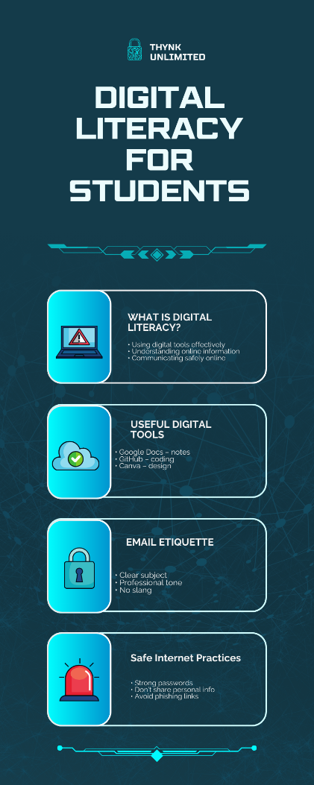
Fig 1: Digital Literacy Infographic created using Canva

Task 2- Digital Portfolio
For Task 2, I created my digital portfolio by setting up profiles on GitHub, LinkedIn, and Kaggle. GitHub is used to showcase coding projects and manage repositories. LinkedIn is a professional networking platform that helps in building connections and exploring career opportunities. Kaggle is used for learning data science and practicing coding.
I plan to use GitHub to upload my projects, LinkedIn to build a professional network, and Kaggle to improve my technical skills over the next four years. This task helped me understand the importance of maintaining a professional online presence.
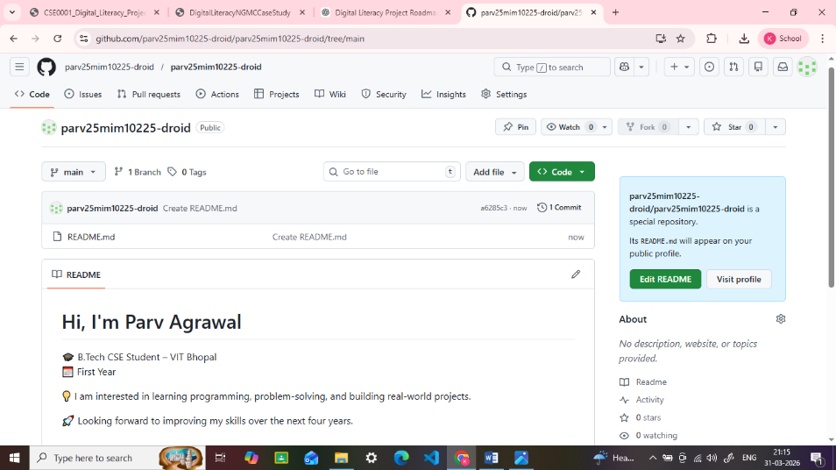
Fig 2:Github Profile
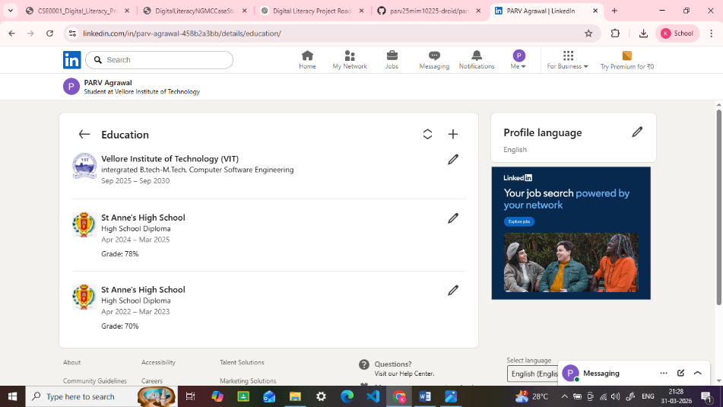
Fig 3:LinkedIn Profile
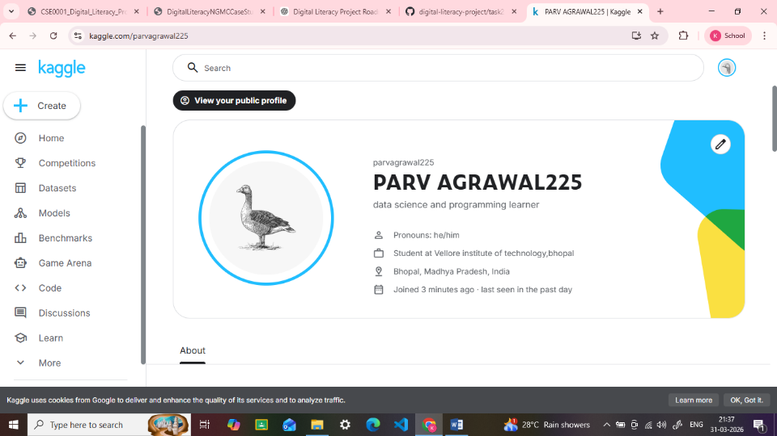
Fig 4:Kaggle Profile
TASK 3-Platforms
For Task 3, I explored coding and collaboration platforms. I used HackerRank to solve a beginner-level problem, which helped me understand basic programming concepts. It improved my logical thinking and coding skills.
I also created a Google Form to test digital literacy awareness. The form included multiple-choice and short-answer questions. Additionally, I linked the responses to a Google Sheet to analyze the data.
These tools will help me improve my academic performance by enhancing my coding skills and enabling better collaboration and data collection.
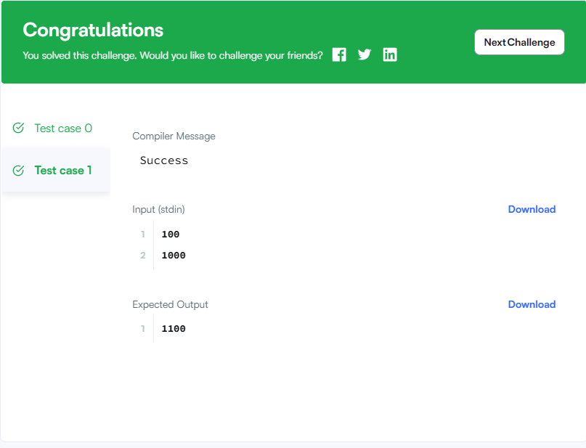
Fig 5:HackerRank challenge
Google Form Link https://docs.google.com/forms/d/e/1FAIpQLSc8LRisxIM9DbNJOS9oGoUYSRP-WWouW992KXpZEERTYv3TjA/viewform?usp=publish-editor
Fig 6:Google form link
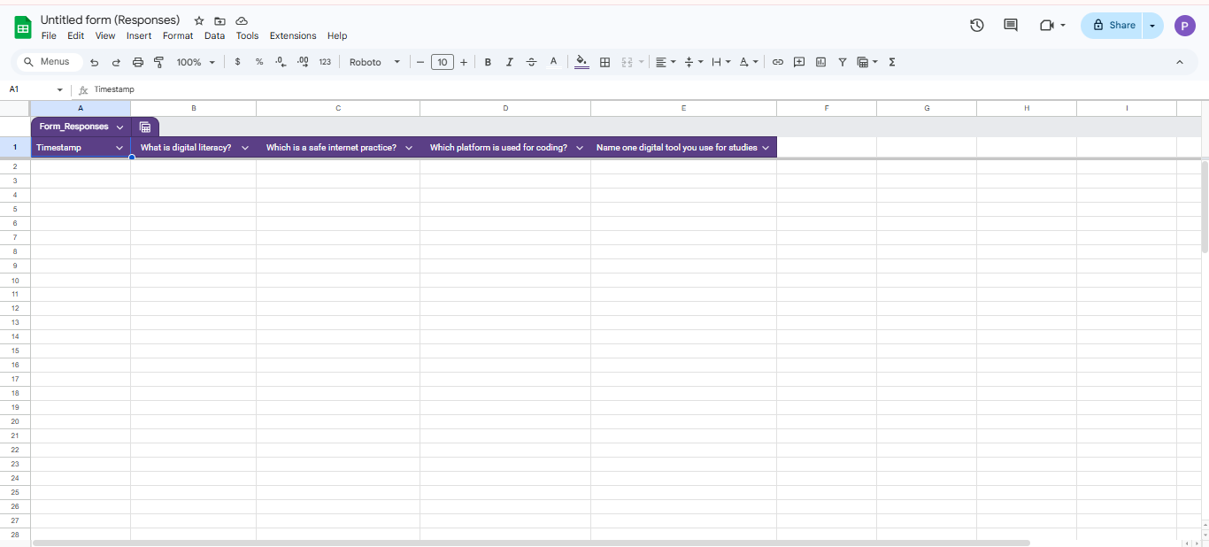
Fig 7:Google Sheet

Task 4-email-etiquettes
In Task 4, I learned about professional email communication and social media etiquette. I wrote two emails, one requesting an assignment extension and another applying for an internship. Both emails followed proper structure, including subject line, greeting, body, and closing.
I also created a checklist of Do’s and Don’ts for responsible social media usage. This task helped me understand the importance of clear communication and maintaining professionalism online.
Poor digital communication can lead to misunderstandings. For example, using informal language or unclear messages in emails can create confusion. This can be avoided by writing clear, polite, and structured messages.

Task5-Cybercrime Case Study
In Task 5, I studied cybercrime awareness by focusing on UPI fraud. I learned how fraudsters trick users into sharing sensitive information or approving fake payment requests. This helped me understand how such scams work and who is usually targeted.
What surprised me the most was how easily people can fall into these traps due to lack of awareness. As a result, I will be more careful while making online transactions and will never share my personal details or approve unknown requests. This task increased my awareness about digital safety.

Conclusion
This project helped me understand the importance of digital literacy in today’s world. I learned how to use digital tools effectively, build a professional online presence, and communicate responsibly. I also gained awareness about cybercrime and online safety. Overall, this project improved my digital skills and confidence.
References
Canva.com
GitHub.com
LinkedIn.com
Kaggle.com
HackerRank.com
forms.google.com
cybercrime.gov.in

